CONGESTIVE HEART FAILURE FORECAST BY HYPOTHESIS TESTING AND ABSTRACTION OF COMORBIDITIES

Navneeth Sreenivasan

(Student ID:801210187)

College of Computing and Informatics

University of North Carolina at Charlotte,

Charlotte, North Carolina, USA

[nsreeni1@uncc.edu](mailto:nsreeni1@uncc.edu)

***Abstract* - Congestive heart failure (CHF) is a chronic progressive ailment that affects the impelling force exerted by heart muscles. While often mentioned simply as heart failure, CHF specifically refers to the phase in which water shapes round the heart and makes it pump unproductively. Hypothesis testing is a statistical technique which is used in creating statistical conclusions using experimental data.  Hypothesis Testing is essentially a postulation that we make about the population parameter. In this study, we see the outcome of Hypothesis Testing on a given data and see whether we reject or accept the Null or Alternate Hypothesis. The statistics for this study was taken from the BIDMC Congestive Heart Failure Database, Health-Data and from the National Vital Statistics System (NVSS) of the Centers for Disease Control and Prevention (CDC) of the United States. We apply Hypothesis Testing on these data by associating the average of the features with the p-value of each of the features and check if they satisfy the 95% confidence interval. Student’s t-test Hypothesis Testing method was chosen. We see that all the features accepted the Null Hypothesis that is, none of them satisfy the 95% confidence limit. Along with that, a list of comorbidities existing in the data were also found.**

***Keywords -* Congestive Heart Failure, Hypothesis Testing, Null Hypothesis, Alternate Hypothesis, Comorbidities**

I. INTRODUCTION

[Heart failure](https://www.webmd.com/heart-disease/heart-failure/default.htm) has marked nearly 6 million Americans. Roughly 670,000 people are detected with heart failure each year. It is the foremost cause of hospitalization in people older than age 65. Congestive Heart Failure is a lingering advanced condition that affects the pumping power of heart muscles. Though frequently referred to only as [heart failure](https://www.healthline.com/health/heart-failure), CHF precisely denotes to the phase in which fluid shapes up round the heart and makes it to pump inefficiently. Left-sided CHF is the most common form of CHF. It happens when the left ventricle does not appropriately pump blood out to your body. As the illness progresses, fluid can build up in your lungs and this makes breathing problematic. There are two types of left-sided heart failure: Systolic and Diastolic Heart Failures. Systolic heart failure befalls when the left ventricle fails to contract ordinarily. This diminishes the level of power available to push blood into motion. Deprived of this force, the heart can’t pump suitably. Diastolic failure, or diastolic dysfunction, ensues when the muscle in the left ventricle turn out to be stiff. Since it can no longer relax, the heart cannot fairly fill with blood between beats.

Right-sided CHF occurs when the right ventricle has trouble pumping blood to your lungs. Blood backs up in your blood vessels, which causes fluid holding in your lower extremities, abdomen, and other major organs. It’s likely to have have left-sided and right-sided CHF at the same time. Typically, the ailment starts in the left side and then travels to the right when left untreated.

There are four stages of CHFs. In Stage 1, we don’t experience any signs during typical physical activity. At this stage, CHF can be managed through lifestyle changes, heart medications and monitoring. In Stage 2, normal physical activity may cause fatigue, palpitations and shortness of breath. At this stage, CHF can be managed through lifestyle changes, heart medications and careful monitoring. In Stage 3, even mild exercises may cause fatigue, palpitations and shortness of breath. Treatment can be complicated at this stage and visiting a doctor may be a good idea. In Stage 4, you cannot carry on any amount of physical activity without symptoms. There’s no cure for CHF at this stage, but there are still palliative care options. A discussion with a doctor is necessary at this stage.

The causes of CHF may include Hypertension, Coronary Artery Disease or other conditions such as Diabetes, Thyroid Disease and Obesity. Some of the symptoms of CHF are fatigue, ankle or knee swelling and weight gain. Chest pain radiating through upper body can also be a sign of Heart Attack. CHF can be diagnosed through Electrocardiogram, Echocardiogram, MRI, Stress Tests, Blood Tests and Cardiac Catheterization and can be treated through drugs or surgeries.

Comorbidities are the concurrent occurrence of two or more diseases or medical conditions in a patient. In the course of medical science, comorbidity is the existence of one or more supplementary conditions often happening alongside a chief condition. Comorbidity describes the consequence of all other conditions an individual patient might have other than the primary condition of interest, and can be physiological or psychological.

II. STATE OF THE ART - BACKGROUND

Value-based Hypothesis Testing for Cardiac Device Clinical Trials [1] by Donald.E.Cutlip, MD and Daniel.B.Kramer, MD, MPH say that a challenge for clinical trial investigators and sponsors is whether valuation of a favourable effect on healthcare value for a new device can be anticipated during the early design phase. Along with starting parameters for end point rates and sample size for testing the principal study hypothesis, this estimate should provide undoubted indication that the new device signifies upgrading in the quality and cost connection or value. In lieu of the not likely situation of indicating dominance for the primary safety and effectiveness end point with a lower estimated cost, the design must depend on secondary measures of better-quality outcomes, including PROMs, and cost estimates linked to these outcomes. Beginning such a value-based theory that is negotiated initially with the CMS during trial design could possibly evade the present extended delay to a compensation decision.

Statistical Methods for Cardiovascular Researchers [2] penned down by Lem Moyé, MD, PhD from University of Texas Health Science Centre’s School of Public Health show the rationale behind arithmetical applications and to examine valuable tools for cardiology research. Both parametric and distribution-free measures of central tendency and dispersion are offered. *T*-testing, analysis of variance, and regression analyses are studied. Survival analysis, logistic regression, and interim monitoring are also discoursed. To conclude, common weaknesses in statistical studies are measured.

Detecting Congestive Heart Failure by Extracting Multimodal Features and Employing Machine Learning Techniques [3] by Lal Hussain, Imtiaz Ahmed Awan, Wajid Aziz, Sharjil Saeed, Amjad Ali, Farukh Zeeshan, and Kyung Sup Kwak from University of Azad Jammu and Kashmir, University of Jeddah, COMSATS University Islamabad and Inha University, Koreapropose an automatic system to analyse HRV signals by taking out multimodal features to capture temporal, spectral, and complex dynamics. Robust machine learning methods, such as support vector machine (SVM) with its kernel (linear, Gaussian, radial base function, and polynomial), decision tree (DT), k-nearest neighbour (KNN), and ensemble classifiers, were hired to appraise the detection performance. The highest performance was gotten using SVM linear kernel, followed by ensemble subspace discriminant and SVM medium Gaussian kernel. The outcomes divulge that the planned tactic can deliver an active and computationally efficient tool for automatic uncovering of congestive heart failure patients.

Usage of Machine Learning Methods for detecting Congestive Heart Failure is still an emerging paradigm. An instance for this is provided in Heart Disease Prediction using Machine Learning Techniques [4] written by Devansh Shah, Samir Patel, and Santosh Kumar Bharti which offers numerous traits related to heart disease, and the prototype on foundation of supervised learning algorithms as Naïve Bayes, decision tree, K-nearest neighbour, and random forest algorithm. It uses the prevailing dataset from the Cleveland database of UCI repository of heart disease patients. The dataset comprises of 303 instances and 76 attributes. Of these 76 attributes, only 14 attributes are considered for testing, significant to validate the performance of different algorithms. This research paper aims to envisage the likelihood of emerging heart disease in the patients. The outcomes depict that the maximum accuracy score is attained with K-nearest neighbour.

Another example which is related to the previous study is found in [5]. Titled Congestive heart failure detection using Random Forest classifier, presented by Zerina Masetic, International Burch University, Bosnia and Herzegovina, and Abdulhamit Subasi, Effat University, Jeddah, Saudi Arabia, this study assessed the outcome of machine learning methods in creating the model which categorizes normal and congestive heart failure (CHF) on the long-term ECG time series. The study was accomplished in two phases: feature extraction phase and classification phase. In feature extraction phase, autoregressive (AR) Burg technique is applied for extracting features. In classification phase, five diverse classifiers are inspected namely, C4.5 decision tree, *k*-nearest neighbour, support vector machine, artificial neural networks and random forest classifier. The investigational results are assessed in numerous statistical measures (sensitivity, specificity, accuracy, *F*-measure and ROC curve) and showed that the random forest technique gives 100% classification accuracy. They concluded with the declaration that Impressive performance of random forest method demonstrates that it plays an important part in sensing congestive heart failure (CHF) and can be valuable in expressing data beneficial in treatment.

A survey study was conducted in [6] which offered the result of Congestive Heart Failure in Elderly patients. This study also found the effect of Left Ventricular Systolic Function with regard to CHF. Named as Outcome of Congestive Heart Failure in Elderly persons: Influence of Left Ventricular Systolic Function, and written by about twelve doctors from around USA, the study appraised the connection between Left Ventricular Systolic Function and Outcome of Congestive Heart Failure in Elderly persons. It was a population-based longitudinal study of coronary heart disease and stroke. Four US cities, Forsyth County, North Carolina, Sacramento County, California, Allegheny County, Pennsylvania and Washington County, Maryland acted as the setting for this project. 5888 people who were at least 65 years of age were recruited by the community. Total mortality, Cardiovascular Morbidity and Mortality were the ones measured. The study found that 269 patients (4.9%) had CHF. Among these, Left Ventricular Systolic Function was normal in 63%, borderline reduced in 15% and overtly impaired in 22%. The mortality rate was 25 deaths per 1000 person-years, 154 deaths per 1000 person-years in participants with CHF and Left Ventricular Systolic Function and 87 and 115 deaths per 1000 person-years in participants with CHF and normal and borderline Systolic Function. Though the risk for deaths from CHF was lesser in patients with normal systolic function than in those with impaired function, more deaths were associated with normal systolic function since more people with heart failure fall into this group.

III. PROPOSED MODEL

A. DEFINITIONS

1. Congestive Heart Failure: Congestive heart failure (CHF) is a chronic progressive condition that affects the pumping power of heart muscles. While often mentioned simply as [heart failure](https://www.healthline.com/health/heart-failure), CHF precisely denotes to the stage in which fluid builds up around the heart and makes it pump unproductively.
2. **Hypothesis Testing: An organized means to select samples from a collection or population with the resolve of producing a determination about the anticipated behaviour of the entire group.**
3. **Null Hypothesis:** The null hypothesis is generally represented as H0. It states the exact opposite of what an investigator or an experimenter predicts or expects. It essentially expresses the statement which states that there is no precise or genuine relationship between the variables.
4. Alternate Hypothesis: The alternate hypothesis is generally represented as H1. It makes a statement that proposes or advises a possible result or a result that an investigator or the researcher may assume.
5. Comorbidities: Comorbidities are the concurrent occurrence of two or more illnesses or medical conditions in a patient.

B. DATA

The proposed model in this application forecasts whether to accept or reject the null or alternate hypothesis in every case. The practice of Hypothesis Testing in Chronic Heart Failure is not a very prevalent research study. This study used datasets from three different resources to take in the data and foresee if each of the datasets gave a Null or Alternate Hypothesis. The information was taken from BIDMC Congestive Heart Failure Database, HealthData (an official website of United States Government), and from the National Vital Statistics System (NVSS) – National Cardiovascular Disease Surveillance Data of the Centers for Disease Control and Prevention (CDC) of the United States.

The first dataset contains long-term ECG recordings from 15 subjects (11 men, aged 22 to 71, and 4 women, aged 54 to 63) with severe congestive heart failure. The individual recordings are each about 20 hours in length of time and comprise two ECG signals each tested at 250 samples per second with 12-bit resolution over a range of ±10 millivolts. This dataset was attained in the form of 15 separate datasets, one for each patient.

The second dataset comprises hospitalization counts and rates, state-wide and by county, for 10 ambulatory care sensitive situations plus 4 composite measures. Hospitalizations due to these medical conditions are possibly avoidable through access to high-quality outpatient care. The conditions include: diabetes short-term complications; diabetes long-term complications; chronic obstructive pulmonary disease (COPD) or asthma in older adults (age 40 and over); hypertension; heart failure; community-acquired pneumonia; urinary tract infection; uncontrolled diabetes; asthma in younger adults (age 18-39); and lower-extremity amputation among patients with diabetes. The composite measures include overall acute conditions, chronic conditions, and diabetes (new, 2016). These statistics deliver a decent initial point for evaluating quality of health services in the public.

The third dataset is appropriated from NVSS, a protected, web-based data management system that amasses and distributes the United States’ official vital statistics. This is one of the datasets provided by the National Cardiovascular Disease Surveillance System. Gauges from this data source have been calculated by employees in CDC's Division for Heart Disease and Stroke Prevention (DHDSP). The system is designed to accommodate multiple indicators from many data sources to deliver a complete image of the public health problem of CVDs and related risk factors in the United States. The data are organized by location (national and state) and indicator; NVSS mortality data include CVDs (e.g., heart failure). The data can be observed by temporal tendencies and stratified by age group, sex, and race/ethnicity.

C. FEATURE SELECTION

Univariate Feature Selection method was hired to select the finest features in the datasets. Univariate Feature Selection works by picking out the best features grounded on univariate statistical tests [7]. We liken each feature to the target variable, to see if there is any statistically substantial relationship between them. It is also called Analysis of Variance (ANOVA) [8]. When we analyse the connection amongst one feature and the target variable, we overlook the other features. Each feature has its test score. To finish, all the test scores are compared, and the features with top scores will be selected.

In this application, Univariate Selection was executed through the use of Python language. The python modules of SelectKBest and f_classif were used. SelectKBest will choose the features according to the k highest scores whereas f_classif will calculate the ANOVA f-value for the provided sample. For each of the 15 sections of the first dataset, we figured the features and later, they were joined together into a single feature for the first dataset. The datasets were fragmented into random training and testing data using the python module of train_test_split. For the second and third datasets, aside from the above-mentioned processes, the score of fitting the model was also calculated which provided us with exceptional outcomes. With these, we saw that the features fit the model in a good manner.

D. RELATIONSHIPS BETWEEN VARIABLES

Graphs were designed for each of the datasets to realize the relationships amongst the variables. In the first dataset, three graphs were plotted for the first three patients to observe the relationship of ECG with Time. In the second dataset, we plot the Count according to ICD9 vs Population according to ICD9, Observed Rate according to ICD9 vs Risk Adjusted Rate according to ICD9) and Count according to ICD9 vs Observed Rate according to ICD9. From the third dataset, we plot the Data Value vs Low Confidence Limit, Data Value vs Year and Low Confidence Limit vs Year.

The figures 3.1 to 3.3 show the data from the first dataset. The data of patients 1,2 and 3 have been denoted in each of the graphs. In the first graph, we see that as time surges, the ECG value keeps on increasing and decreasing but it never is bigger than the value of time. They have a linear relationship. The second graph also shows the same, that is, we see that as time increases, the ECG value also increases but it is never larger than the value of time. They also have a linear relationship. We also see that in many cases, ECG value does not decrease with time, but stays constant, as shown by the empty spaces as time increases. The third graph is not any different, that is, as time increases, the ECG value also increases but it is never larger than the value of time. Even they have a linear relationship.

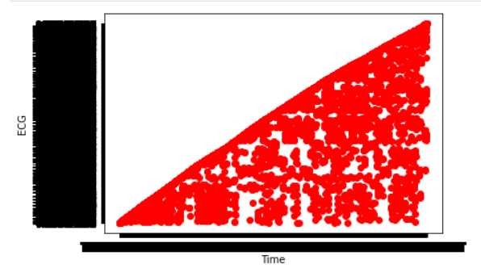

(Fig 3.1: ECG vs Time of Patient 1)

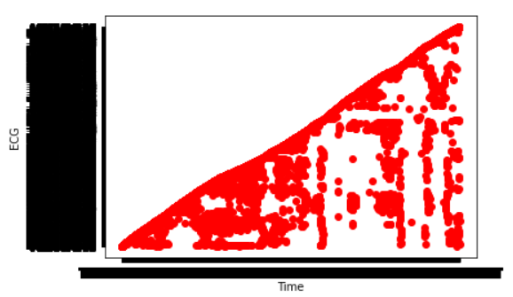

(Fig 3.2: ECG vs Time of Patient 2)

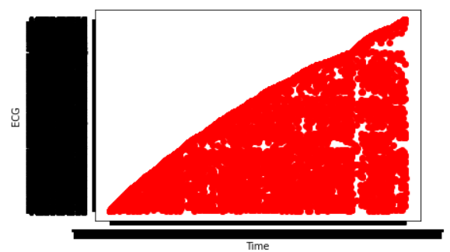

(Fig 3.3: ECG vs Time of Patient 3)

The figures 3.4 to 3.6 show the data from the second dataset. They show the results of Count_ICD9 vs Population_ICD9, ObsRate_ICD9 vs RiskAdjRate_ICD9 and Count_ICD9 vs ObsRate_ICD9 respectively. In the first plot, we can see that Population_ICD9 is almost always larger than Count_ICD9, with the exception of a few. In the second plot, we cannot discern any pattern at first, but on a closer inspection, we can see a linear growth among both the axis values. In the third plot, again, we can say that there is a linear relationship that exists among the values. However, in the third graph, not a lot of values appear to be at the high extremes. This is in contrast to the second graph, where there are numerous values in the high extreme. Nevertheless, in all the three graphs, we can see that there are more values in the lower extremes compared to the higher extremes.

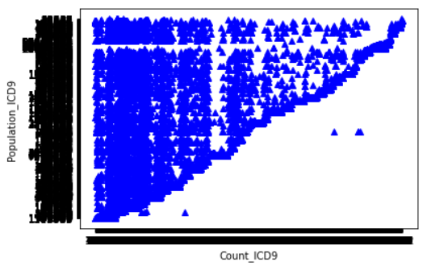

(Fig 3.4: Count_ICD9 vs Population_ICD9)

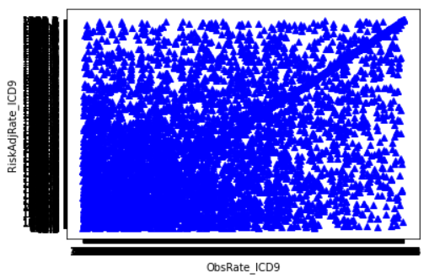

(Fig 3.5: ObsRate_ICD9 vs RiskAdjRate_ICD9)

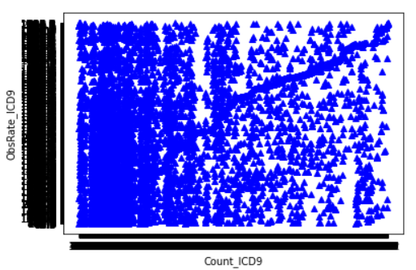

(Fig 3.6: Count_ICD9 vs ObsRate_ICD9)

The figures 3.7 to 3.9 show the data from the final dataset. They show the plots of Data Value vs Low Confidence Limit, Data Value vs Year and Low Confidence Limit vs Year respectively. In the first graph, we can observe that some of the Low Confidence Limit values are high compared to the Data Value values, whereas some are low. Most of the times, as Data Value increases, Low Confidence Limit remains constant, or in rare cases, increases. We can see that after the Data Value reaches 2500 approximately, Low Confidence Limit is constant. The second and third graphs are plotted as horizontal and vertical lines respectively since Year is constant. In the second graph, we can see that each Year, most of the range of the Data Values lie in the lower range, whereas in the third graph, we can see that each Year, Low Confidence Limits exists in both the lower as well as the higher ranges, with values appearing rarely in between 2500 and 3000.

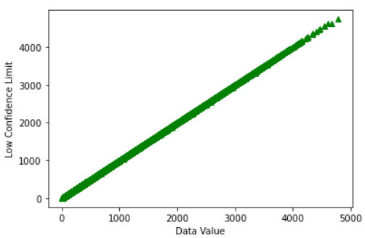

(Fig 3.7: Data Value vs Low Confidence Limit)

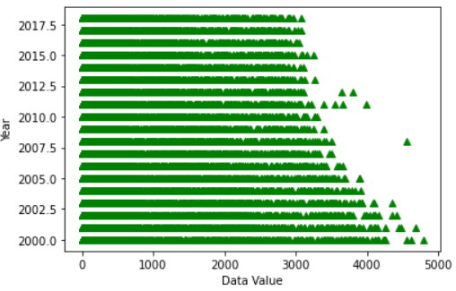

(Fig 3.8: Data Value vs Year)

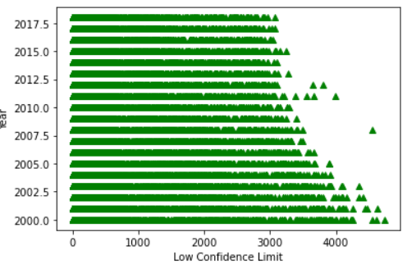

(Fig 3.9: Low Confidence Limit vs Year)

E. COMORBIDITY EXTRACTION

Comorbidity has also been used to convey the idea of burden of illness or disease, defined by the total burden of physiological dysfunction or the total burden of types of illnesses partaking an influence on an individual’s physiologic reserve [9]. In the first dataset, we abstract the ECG values and compute the Heart Rate from the ECG values. 0.1 mV ECG = 1 mm = 0.04 sec. After altering to seconds, we double it and then convert it to minutes, to get the number of beats per minute. 60-100 beats per minute is the normal range. Less than that produces an ailment called Bradycardia and more than that produces an ailment called Tachycardia.

For the second and third datasets, to extract comorbidities, we analyse if there are any duplicate data, ignoring the column selected. This is because for the second dataset, we do not know the conditions of each individual patient, and for the third dataset, again, we do not have any specific identity for the patient. Therefore, we take that if duplicate data is present, then it means that there exists a comorbidity. Here, we keep the duplicate data in a separate dataset called duplicate. If the duplicate dataset is not null, then there exists duplicate data, and hence exists a comorbidity. Otherwise, if the duplicate dataset is null, then no comorbidity exists.

IV. RESULTS

A. HYPOTHESIS TESTING

The Hypothesis Testing mechanism is demonstrable on the base of observed data modelled as the realised values taken by a gathering of random variables. For each of the datasets, one null hypothesis and one alternate hypothesis [10] has been assumed and the outcomes are shown below. Student’s t-test is the hypothesis testing technique taken. We compare the p-value obtained with the mean of each column.

From the table given, we can see that for all the datasets, null hypothesis was accepted and the alternate hypothesis was rejected. We compared the mean of each of the features with each of the values in the corresponding features for every dataset. Student’s t-test method was chosen as the Hypothesis Testing method. The null hypothesis and alternate hypothesis chosen are –

H0: P-value is greater than 0.05 (Null Hypothesis)

H1: P-value is less than 0.05 (Alternate Hypothesis)

|  |  |  |
| --- | --- | --- |
| Dataset | P-value obtained | Inference |
| Dataset – 1 | 1 | Null Hypothesis accepted |
| Dataset – 2 | 1 | Null Hypothesis accepted |
| Dataset – 3 | 1 | Null Hypothesis accepted |

(Table 4.1 Results of Null or Alternate Hypothesis Testing)

After finding the p-value for the datasets, we applied 95% confidence limit on the datasets and found that for each of the datasets, the p-values turned out to be 1. Therefore, for each of the datasets, the Null Hypothesis turned out to be true. Hence, for every dataset, the Alternate Hypothesis was rejected and the Null Hypothesis was accepted.

B. COMORBIDITY EXTRACTION

In the first dataset, most of the patients tested out with comorbidities. The heart rate between 60-100 is thought of as normal. The heart rate less than 60 is a condition called Bradycardia (Slow Heart) [11] and that above 100 is called Tachycardia (Fast Heart) [12]. Along with Bradycardia, other diseases include Sick Sinus Syndrome, Hyperkalaemia etc. while along with Tachycardia, other diseases include Cardiomyopathy, Atrial Fibrillation, Hypokalaemia etc. Out of the 15 patients, patients 3,9 and 11 had no comorbidity, whereas all the other patients had Bradycardia (Slow Heart), Sick Sinus Syndrome and Hyperkalaemia.

For the second and third datasets, we are not given if the data belongs to one patient or more than one patient. So, we check the duplicate data to see if the same patient is registered under two different diseases. To check if the patient is the same or not, we check the other details of the patient, such as Year, Place, PQI, Disease Name, Age etc. and check if there is any duplicate data. No duplicate data was generated for both the second and third datasets; hence, we can say that no one suffers from comorbidities in datasets two and three.

V. CONCLUSION

Comprehensive care, differential diagnosis, and continuance of care are vital aspects of primary care. These values are emphasized in the chiropractic clinical curricula and carried through chiropractic patient management. Holistic care delivered with compassion but guided by rigorous science is in the best interest of the patient. A much-needed stimulation investigation is needed in this critically significant area of patient care. This study showed us the results of Hypothesis Testing in Congestive Heart Failure and also hauled out the comorbidities present in the data. We see that the Student’s t-test method resulted in acceptance of Null Hypothesis, where we compared all of the feature data with the mean of the feature data. An interesting scenario would be to use a different type of Hypothesis Testing method rather than use Student’s t-test on the data. Another interesting take is that instead of comparing all the feature data with the mean, we could randomly select any one feature data and then compare it with the mean. We could also compare the feature data with the mode or median. This could result in a large number of possibilities. The abstraction of comorbidities could also have been done in a more refined way than has been done in the current study.

VI. REFERENCES

1) Kutlip. D.E, MD and Kramer. D. B, MD, MPH; Value-Based Hypothesis Testing for Cardiac Device Clinical Trials; *Circulation: Cardiovascular Interventions*; 2016; 9-5; [https://doi.org/10.1161/ CIRCINTE RVENTIONS.116.003627](https://doi.org/10.1161/%20CIRCINTE%20RVENTIONS.116.003627)

# 2) Moyé L; Statistical Methods for Cardiovascular Researchers. *Circulation Research*; 2016; 118-3: pp 439-453; doi:10.1161/CIRCRESAHA.115.3063 05

3) Hussain.L, Awan.I.A, Aziz.W, Saeed.S, Ali.A, Zeeshan.F and Kwak.K.S; Detecting Congestive Heart Failure by Extracting Multimodal Features and Employing Machine Learning Techniques; *BioMed Research International;* 2020; https://doi. org/10.1155/2020/4281243

4) Shah, D., Patel, S. & Bharti; S.K. Heart Disease Prediction using Machine Learning Techniques; *SN COMPUTER SCIENCE*; 2020; 1-345; https://doi .org/10.1007/s42979-020-00365-y

5) Masetic Z, Subasi A. Congestive heart failure detection using random forest classifier; *Computer Methods and Programs in Biomedicine;* 2016; 130: pp 54-64; doi: 10.1016/j.cmp b.2016.03.020.

6) Gottdiener JS, McClelland RL, Marshall R, Shemanski L, Furberg CD, Kitzman DW, Cushman M, Polak J, Gardin JM, Gersh BJ, Aurigemma GP, Manolio TA; Outcome of congestive heart failure in elderly persons: influence of left ventricular systolic function. The Cardiovascular Health Study. *Annals of Internal Medicine*; 2002; 137-8; pp 631-639; doi: 10.7 326/0003-4819-137-8-200210150-00006.PMI D:12 379062.

7) Chakraborty.S and Goswami.S and Saha.H; An Univariate Feature Elimination Strategy for Clustering Based on Metafeatures; *International Journal of Intelligent Systems and Applications*; 2017; 9. 10.5815/ijisa.2017.10.03.

8) Ståhle.L and Wold.S; Analysis of variance (ANOVA); *Chemometrics and Intelligent Laboratory Systems*; 1989; 6-4; pp 259-272; https:// doi.org/10.1016/0169-7439(89)80095-4

9) Valderas JM, Starfield B, Sibbald B, Salisbury C; Roland M. Defining comorbidity: implications for understanding health and health services; *Annals of Family Medicine*; 2009; 7-4; pp 357-363; doi:10.13 70 /afm.983

10) Anderson, D., Burnham, K., & Thompson, W; Null Hypothesis Testing: Problems, Prevalence, and an Alternative; *The Journal of Wildlife Management;* 2000; 64-4; 912-923; doi:10.2307/3803199

11) Sidhu.S, Marine.J.E, Evaluating and managing bradycardia; *Trends in Cardiovascular Medicine*; 2020; 30-5;pp 265-272; <https://doi.org/10.1016/j.tc> m .2019.07.001.

12) Gopinathannair R, Olshansky B; Management of tachycardia; *Faculty of 1000 Prime Reports*; 2015; 7-60. doi:10.12703/P7-60